
PVG Applicant’s Guidance

for Volunteers aged 15 (paper application)
This document explains the process of applying for a PVG Disclosure (also called a criminal records check) for The Scouts if you are

- already helping support younger Scouts as a Young Helper or within the Young Leader or Duke of Edinburgh scheme in Scotland.
- aged 15 (you can start your PVG application at 15 yrs and 8 mths)

Why do I need a PVG Disclosure?

The PVG Disclosure is an important part of keeping young people safe in Scouting. More information on the PVG scheme can be found here: Protecting Vulnerable Groups (PVG) scheme - mygov.scot

Your work supporting younger Scouts is defined as a ‘Regulated Role’ because it involves being in charge of children whilst instructing them in their activities so your criminal records check will be at the PVG (Protecting Vulnerable Groups) level. You do not need to pay for it as you are a volunteer.

In Scotland, PVG disclosures are not just a single check, PVG is an ongoing scheme that you join. After your first disclosure (PVG result), if there is any new criminal information, your employer (Scouts HQ) would be kept updated.

If you already have PVG membership and have had a PVG disclosure for another organisation, you will still need to apply for a Scouts’ PVG disclosure so Disclosure Scotland know they can share information with Scouts. The application form is slightly different- there is guidance at the bottom of this document.

How do I apply?

- On or after your 16th birthday, you can apply to join the PVG scheme using the same Scouts’ online process as adult members which includes a ScotAccount. You would not be able to volunteer with younger Scouts until your PVG disclosure is received and the Scouts’ vetting process has completed.

- If you are not yet 16, you can be added to scouts.org.uk when you are aged 15 years and 8 months, The PVG application is a different process without a ScotAccount. By applying at this age, we hope that your PVG disclosure is received and assessed by Scouts’ HQ before your 16th birthday so you won’t need to stop volunteering. The application process is slightly different- you can find further information about this process below.

In both cases, once you turn 16, you can only volunteer as a Young Helper, Young Leader or Duke of Edinburgh participant once your PVG disclosure has been received and risk assessed at HQ, even if you already hold a PVG disclosure for another organisation.

These rules apply even if you are only volunteering for one day or a short period of time, such as 3 months for the Duke of Edinburgh Bronze award.

What if I have a caution, conviction or police information that will show on my PVG disclosure?

If you have cautions, convictions or other adverse police information on your PVG disclosure, this does not automatically stop you from volunteering with The Scouts. The information will be risk assessed by the Scouts’ Safeguarding Team at HQ and they may involve your District Lead Volunteer.

Any criminal information will only be shared with the adults involved in the Scouts’ vetting process to enable them to make a decision about your suitability to hold the role. As you are still a young person in Scouting, your parents may need to be involved but this would be discussed with you first. If you have adverse information on your check and also have an Explorer role in Scouting, the HQ Safeguarding Team would talk to you about whether it affects that role.

What happens when I become 18?

- If you would like to continue volunteering with an adult role when you are 18, you wouldn’t need to apply for a new PVG disclosure however, any known adverse information may be risk assessed again by HQ, considering the responsibilities of your new role.

- If you do not wish to become an adult leader when you become 18, your Young Leader/ Duke of Edinburgh / Young Helper role would end and Scouts HQ would notify Disclosure Scotland that you had left the PVG scheme.

What information is stored about me?

Your personal data will be stored on the Scouts’ membership system at scouts.org.uk to support your PVG application process. Your volunteer line managers will be able to see the application information held about you in the membership system. Other members of your group will be able to see your name only. If you continue in Scouting when you turn 18 your membership record will become a full adult record, and if you do not, your account will be closed and the data kept on the system for 10 years.

When your PVG disclosure is complete, any adverse or criminal information provided to us may be shared with members of the HQ Safeguarding Team and senior Local Volunteers; and used to make a decision about your suitability to hold a role. Scouts may also need to share the information with statutory agencies such as the Local Authority. The information will be securely retained on the Scouts’ HQ confidential safeguarding database in line with the Data Retention Policy For more information about how Scouts use your data please see the Data Protection Policy

For information about how Disclosure Scotland use your data please see Disclosure Scotland's privacy statement - mygov.scot

THREE- STEP APPLICATION PROCESS (ID Meeting- PVG application form- Sharing result)

- Meeting to review your Identity Documents and complete your Application Form

You will be asked to meet a member of The Scouts’ local team so they can help you complete your PVG application form; view your original identity documents and complete your application on the membership system (scouts.org.uk). You may wish for your parent(s) to accompany you to that meeting for assistance.

Before the meeting
Please log on to the membership system via scouts.org.uk to complete your personal details. You may wish to start completing the PVG application form (please see guidance below)

Please take with you to that meeting:
- One original document from List A which shows your name and date of birth AND
- One original document from List B which shows your name and current address
(at least one of these two documents must be photographic) AND
- Another original document from List A, B or C AND
- Proof of any name changes

If you have legally changed your name you will need to declare this on the PVG application form and show any documents about this to your ID checker. If you don’t have documents, please discuss this with your ID Checker.

At the meeting
The ID checker will need to see the original documents – not photocopies or documentation printed from the internet e.g. internet bank statements. You cannot use the same document for both date of birth and address.

The ID Checker will take a colour scan or photo of your ID documents as Disclosure Scotland require them as part of the application. The ID Checker will complete the application form with you then upload the form and ID scans/photos to The Scouts’ membership system. The Disclosure staff in the HQ Safeguarding Team will check and countersign your application then send the form and copies of ID to Disclosure Scotland.

List of Acceptable ID
Note: You cannot use the same document for both date of birth and address.

List A: Identity documents which include date of birth
Current passport
Current driving licence (full or provisional)
Young Scot Card / National Entitlement Card
Biometric residence permit
National identity card from a country outside the European Economic Area
Birth certificate
Adoption certificate
Marriage certificate or civil partnership certificate
NHS card
UK armed forces identity card
UK firearm or shotgun certificate
List B: Identity documents which show your name and include your current address
Your proof of address must be no more than 12 months old, although your driving licence can be older
UK Hospital or doctor's letter
University, college or school letter
Payslip or P60
Utility bill, such as gas, electric or phone bill (not mobile) - Must be less than 3 months old
Bank statement- Must be less than 3 months old
Driving licence photocard (full or provisional)
Tenancy agreement (typed, not handwritten)
Insurance policy document or letter
Council tax bill or letter
UK TV Licence
UK Electoral Register Office letter or UK polling card
Home Office letter
UK firearm or shotgun certificate
UK solicitor's letter on headed paper
List C: Photographic Documents
Current Passport
Driving Licence photocard (full or provisional)
National ID Card / Young Scot Card

2a. How to complete the PVG Application Form – Guidance Notes for NEW applicants
Please check your spelling is correct. Use capital letters

Section 1: Application
If you already have a PVG disclosure for another organisation, scroll down this document to the guidance 2b guidance for Applicants Who Already Have a PVG Disclosure.

If this is your first PVG application, continue with the guidance in this section.

You are ‘joining’ the PVG scheme and you’ll be working with ‘Children’. Tick the box next to ‘PVG scheme disclosure (Join)- Children

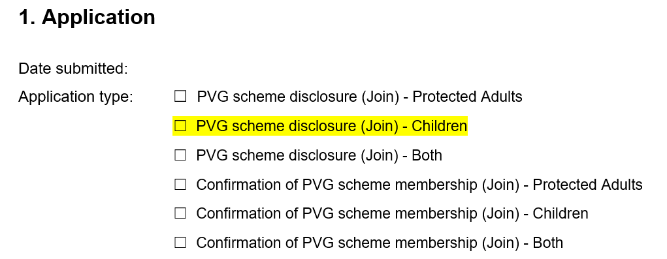

Section 2: Names
Enter all current legal names and previous names including ALL middle names.

Section 3: Birth details
Enter Birth Details as requested. ‘Gender’ means Legal Sex.

Section 4: Your current address
Enter your current address and all addresses you have lived at in the past 5 years.

Section 5: Your contact details

It is important to enter your contact details so Disclosure Scotland can ask you about sharing your result with Scouts HQ.

Section 6: Identifying information
Enter information as requested, checking numbers are correct

Section 7: Regulatory body details
You do not need to complete this – this will be done at Scouts HQ.

Section 8: PVG membership details
You will not need to complete this unless you already have a PVG Disclosure.

Section 9: Declaration on application
Please read this carefully then sign and date it. It’s best if you do this in your meeting with the ID Checker,
in case there are any changes needed.

Section 10: Payment
Leave this section blank

The rest of the form is completed by the Countersignatories in the HQ Safeguarding Team. You do not need to enter anything else.

2b. Applicants who ALREADY have a PVG Disclosure - How to complete the PVG Application Form for Scouts

Section 1: Application
If you already have a PVG disclosure for another organisation, you are ‘Confirming your PVG scheme membership’ and ‘Joining’ Scouts, working with Children.

Tick the box next to ‘Confirmation of PVG scheme membership (Join)- Children

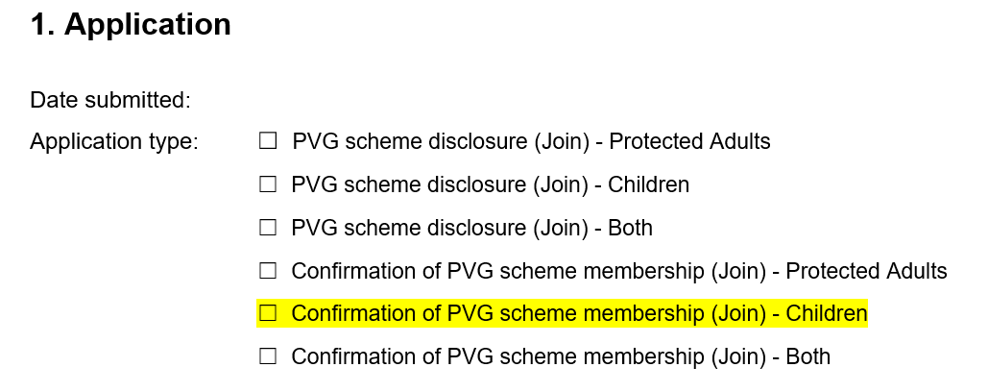

Section 2: Names
Enter all current legal names and previous names including ALL middle names.

Section 3: Birth details
Enter Birth Details as requested. ‘Gender’ means Legal Sex.

Section 4: Your current address
Enter your current address and all addresses you have lived at in the past 5 years.

Section 5: Your contact details

It is important to enter your contact details so Disclosure Scotland can ask you about sharing your result with Scouts HQ.

Section 6: Identifying information
Enter information as requested, checking numbers are correct

Section 7: Regulatory body details
You do not need to complete this – this will be done at Scouts HQ.

Section 8: PVG membership details
Enter your 16-digit PVG membership number. You’ll find this on your previous PVG disclosure under your date of birth. The PVG number will start with the year you joined the PVG Scheme, e.g. if you joined in 2024, it will start with ‘24’.

Section 9: Declaration on application
Please read this carefully then sign and date it. It’s best if you do this in your meeting with the ID Checker,
in case there are any changes needed.

Section 10: Payment
Leave this section blank

The rest of the form is completed by the Countersignatories in the HQ Safeguarding Team. You do not need to enter anything else.

- Receiving the Outcome of your PVG disclosure

When Disclosure Scotland have finished their checks, they will ask you if you are happy for your result to be ‘Shared’ with your employer (This will be The Scouts HQ as they applied for the check)

The Scouts HQ will not be able to see the detail on your PVG disclosure unless you agree for it to be ‘Shared’.

You will need to ‘Share’ your PVG result with The Scouts HQ, even if its clear. (If you don’t agree to sharing it, you would have to stop helping with younger Scouts, even if you have a PVG disclosure for another organisation) Your PVG disclosure must be shared with Scouts HQ within 14 days of receiving it. If you do not ‘share’ your result with Scouts HQ within that timeframe, you would need to start the application process again.

If you do forget to ‘Share’ your outcome with The Scout Association you can contact the Disclosures staff in the HQ Safeguarding Team via Disclosures@scouts.org.uk

Even if you have a PVG disclosure for another organisation, you will still need a Scouts PVG disclosure before you volunteer with young people in Scouting.

If your PVG disclosure contains some adverse (negative) criminal information, the HQ Safeguarding Team will need to risk assess it so you may not be able to help with younger Scouts straight away. If you also have an Explorer role in Scouting, the HQ Safeguarding Team will talk to you about whether it affects that role.

If you have any queries about this process, you can contact the Disclosures staff in the HQ Safeguarding Team via Disclosures@scouts.org.uk

