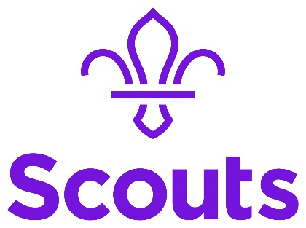
<Date>
Dear <adult’s name>,
Thank you so much for getting in touch, it’s great to hear that you’d like <child’s name> to join our Scout Group!
At the moment, we’re fully subscribed and our volunteer teams aren’t able to take on any more young people, so I’ll add you to our waiting list. Please could you let me know the following:
- Child’s name
- Child’s date of birth
- Adult's name
- Email address
- Contact number
- Postcode
I think we can offer you a space in <month> but there are a number of factors that affect this, so I can’t promise anything right now.
When there is a space for you, I’ll pop you an email to let you know and you’ll have 7 days to respond. If I don’t hear anything back, I’ll presume that you no longer need it and I’ll offer it to the next person on the list.
Each term I’ll check in and see if you’d still like to be on the list, please get back to me as soon as you can either way, so I can make sure our list is up to date.
I’m sure you’d like <child’s name> to get a place as soon as possible, so if you would like to see if there are other local Scout Groups with space, please get in touch with <Group/District Lead Volunteer> on <email address> who will be able to give you some more information.
For more information on Scouts and what your child will get up to with us, check out our website: What do Scouts do? | Scouts
If you have any further questions, please don’t hesitate to get in touch.
Many thanks,
<Your name>
<Your role>

