XXX Open Event
Time | Activity | Resources | Who
19:00 | Welcoming arrivals | - Table by the door  - Register of all those invited  - Emergency contact sheet for all those not already part of the Group
19:00 – 19:40 | Juggling balls | - Balloons  - Rice  - Scissors  - Small sandwich bags
19:00 – 19:40 | Newspaper towers | - Old newspapers  - Sellotape
19:00 – 19:40 | Smores | - Marshmallows  - Skewers/sticks  - Biscuits  - Wood/kindling  - Matches  - Bucket of water
19:00 – 19:40 | Mini catapult making | - Rubber bands  - Lollipop sticks  - Wooden spoons  - Something small to fling (e.g. mini marshmallows, peas, paperclips…)
19:00 – 19:40 | Paper airplane competition | - Paper  - Design ideas  - Tape measure
19:00 – 19:40 | Biscuit decorating | - Rich tea biscuits  - Liquid icing  - Sprinkles  - Other decorating bits
19:00 – 19:40 | Mini parachutes | - Tissue paper  - String or wool  - Pipe cleaners (to make people)  - Scissors  - Colouring pencils  - Sellotape
19:40 – 20:00 | Adult talk  (Adults only) | - Projector  - Laptop  - Table  - Skills surveys  - Pens/pencils | XXX to lead, GSL and Chair to support
19:40 – 20:00 | Game outside/campfire songs |  | All other volunteers

Juggling Balls
Per ball, you will need:
- 2 balloons
- A sandwich bag
- A handful of rice
- Some scissors

Step 1
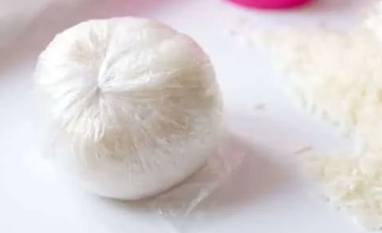
Put a small handful of rice into the sandwich bag and tie a knot in the bag.

Step 2
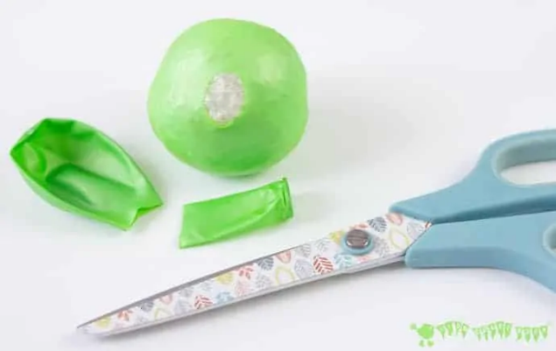
Cut the necks off both of the balloons.

Step 3
With the help of a friend, stretch one of the balloons over the bag of rice.

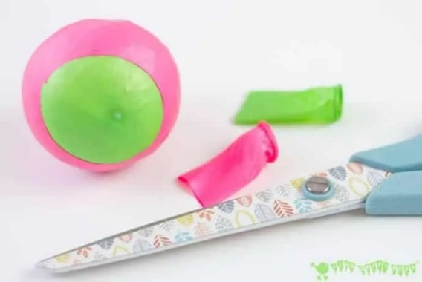
Step 4
Then stretch over the other balloon in the opposite direction so that holes in the balloons are on opposite sides.

Step 5
Have fun juggling with your new juggling balls!
Spaghetti Towers

You will need:
- Spaghetti
- 4 Marshmallows

Make the tallest tower out of only spaghetti and 4 marshmallows. The tower must be freestanding (not leaning on anything) for at least 10 seconds to count!
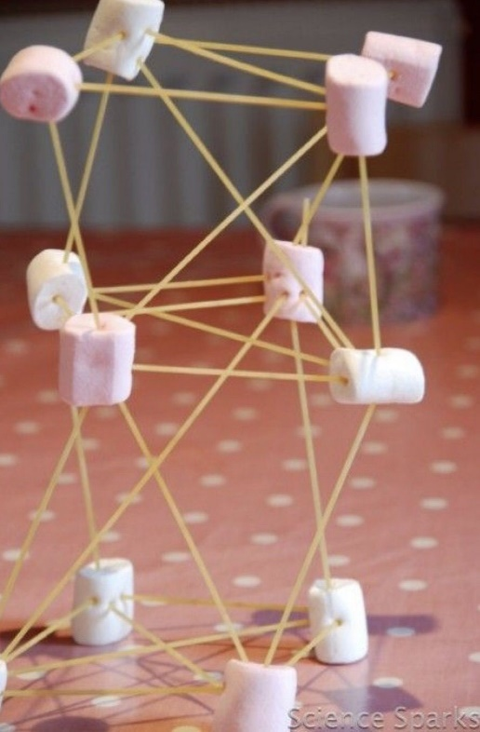
Newspaper Towers
You will need:
- Lots of newspaper
- Some sticky tape

Make the tallest freestanding tower out of just newspaper and tape. It must not be leaning on anything and must stand unaided for at least 10 seconds for it to count.

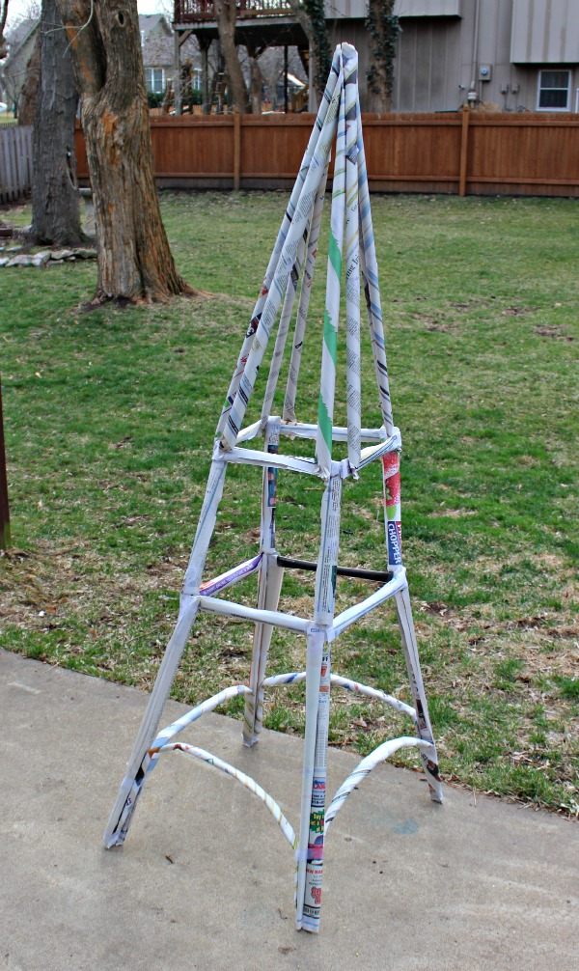
Smores

You will need:
- A marshmallow
- 2 biscuits
- A skewer or stick

Put a marshmallow on the end of a stick and use it to hold the marshmallows over the fire. When it starts melting, take two biscuits and use them to squeeze the marshmallow off of your skewer.

Don’t eat your smore straight away because it will be VERY hot

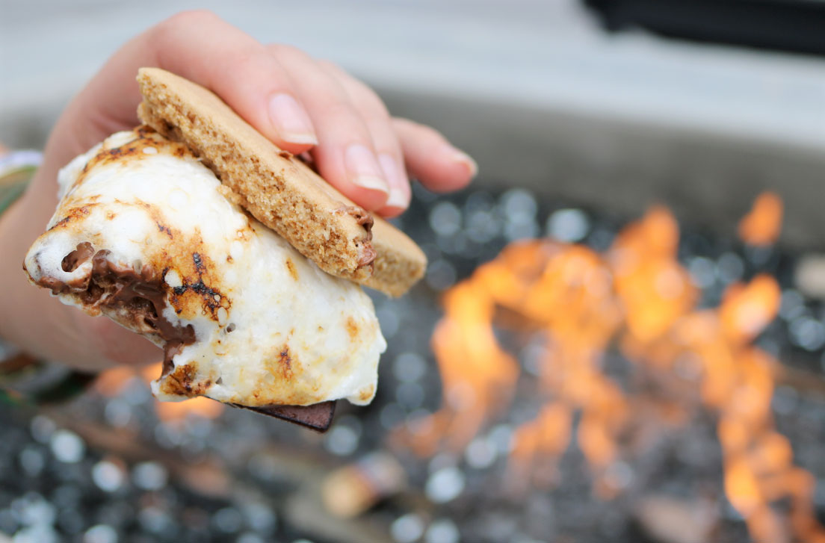
Mini Catapults

Per catapult, you will need:
- 4 Rubber bands
- 6 Lollipop Sticks
- 1 Wooden Spoon

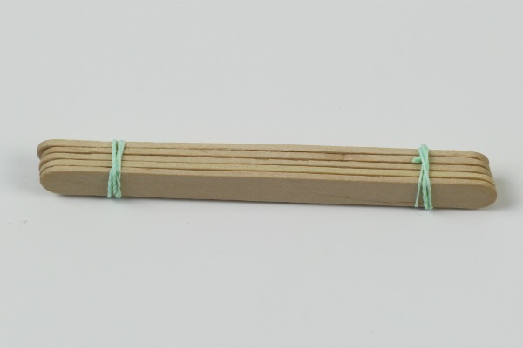
Step 1
Stack 5 lollipop sticks on top of each other and wrap a rubber band around each end.

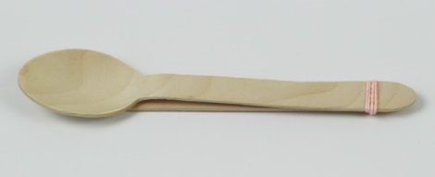
Step 2
Stack the wooden spoon on top of the other lollipop stick and wrap a rubber band around one end.
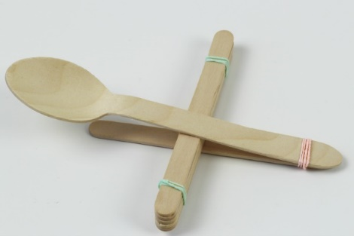
Step 3
Separate the spoon and lollipop stick at the other end and slide the stack of 5 sticks in between them.
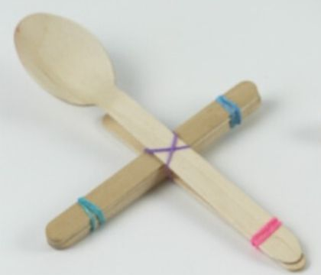
Step 4
Wrap a rubber band around the middle to hold the spoon and the sticks in place.

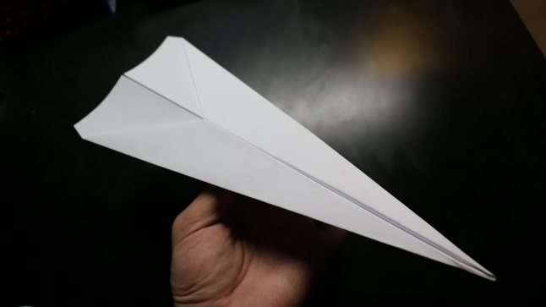
Paper Aeroplane Competition
You will need:
- Paper
- Some design ideas: Fold 'N Fly » Paper Airplane Folding Instructions (foldnfly.com)
- Tape measure
- Something to write down distances on

Everyone has the chance to make a paper aeroplane and throw it from a starting line. The distance thrown is measured and added to a scoreboard. They can create as many different aeroplanes as you have the resources for them to do, and they can throw as many times as they want.

Biscuit Decorating
You will need:
- A biscuit
- Icing
- Sprinkles and other toppings

Decorate a biscuit with a Scout-theme. Maybe the Scouts logo, a favourite Scout activity or the Scouts promise would go nicely on a biscuit!

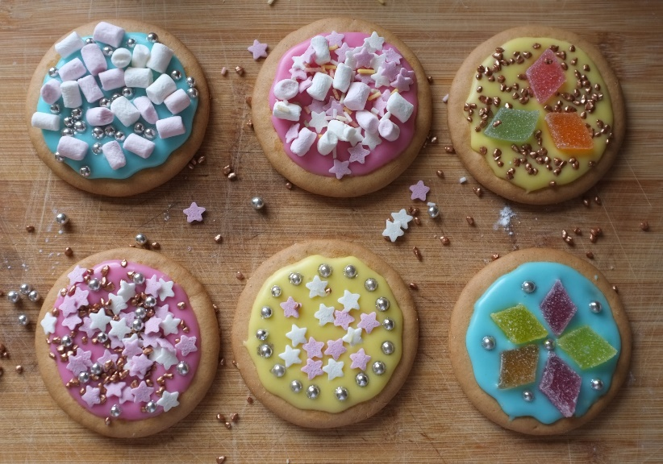
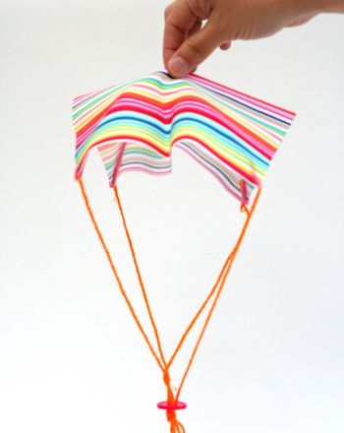
Mini Parachutes
You will need:
- Tissue paper
- String or wool
- Pipe cleaners
- Scissors
- Sticky tape

Step 1
Cut a square piece of tissue paper

Step 2
Cut four equal lengths of string about 20cm long

Step 3
Attach one end of each length of string to each of the four corners of the paper. You could tape it or tie it, it’s up to you.

Step 4
Bend a pipe cleaner into the shape of a person, a star or maybe an animal.

Step 5
Tie or tape the other end of each piece of string to your pipe cleaner figure,

Step 6
Throw it up in the air and watch it all float safely down to the ground!

