Welcome to the XXXX
Scout Group Taster Event!


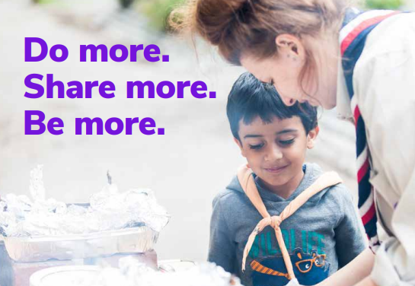

scouts.org.uk/join
#SkillsForLife

Squirrels, Beavers, Cubs, Scouts, Explorers

Water Bomb    | Pop Bottles   
Making Fire    | Marshmallows   
First Aid    | Shoe Laces   
Edible Knots    | Map Symbols   

Thank you for joining us today!

We hope you had a great time, and enjoyed our taste of Beavers. Our group meets at the Scout
Hut, Church Road, Newtown and we cater for young people from 4 to 18 years old.

Squirrels: Saturday 10:00 – 11:00 (4-6 year olds)
Beavers: Mondays 6:30 – 7:30pm (6-8 year olds)
Cubs: Tuesday 6:30 – 7:45pm (8-10 year olds)
Scouts: Thursday 7:30 – 9:00pm (10-14 year olds)

Come along to the next session or contact:
<Name> <email> <Mobile> for more information

