Group Name

Preparing young people with skills for life

New Adult Volunteer

General Information Pack

Welcome
On behalf of all the young people and adults of the Scout Group, I would like to thank you for the interest you have shown in volunteering to become an ‘Adult in Scouting’.

Scouts is the most successful youth movement in the world, with a rich history, achieved thanks to volunteers who give up some of their precious time. Adults in Scouting have accepted the challenge of helping young people grow, and develop socially, spiritually, intellectually and physically - but it’s more than that, as an adult in Scouting you can:

- give something back to the community
- support the Leaders
- spend more quality time with your child
- enjoy and rediscover adventure for yourself
- volunteer and know it is a ‘good thing’
- be an enabler, so the Leaders can do more
- develop your own skills
There are many ways as an adult you can help in Scouting, just some of the various roles can be seen below, and specifically the roles within our Group are:
- Section Assistants
- Occasional Helper/Parent
- Fundraisers
- Chairman/Secretary/Treasurer
- Assistant Leaders
- Leader / Group Scout Leader
- Scout Active Support
Information about some of these roles appears in this pack, but if you would like to know more you can speak to me, or check out the details on the Scout Association website – www.scouts.org.uk
I hope you enjoy reading the rest of this introduction into Scouting and our Scout Group, and I urge you to ask as many questions as you need.
Thank you again for volunteering
Thanks,
Name
Group Scout Leader

About us
Overview of Scouting

We are the UK’s biggest mixed youth organisation. We change lives by offering 4-to-25-year-olds fun and challenging activities, unique experiences, everyday adventure and the chance to help others so that we make a positive impact in communities.
Scouts helps children and young adults reach their full potential. Our members gain valuable skills for life including teamwork, time management, leadership, initiative, planning, communication, self-motivation, cultural awareness and commitment. We help young people to get jobs, save lives and even change the world.

What do Scouts do?

Scouts take part in a wide range of activities as diverse as kayaking, abseiling, expeditions overseas, photography, climbing and zorbing. As a Scout you can learn survival skills, first aid, computer programming or even how to fly a plane. There’s something for everyone. It’s a great way to have fun, make friends, get outdoors, express your creativity and experience the wider world.

What do volunteers do?

This everyday adventure is only possible thanks to our team of adult volunteers, who support Scouts in a wide range of roles from working directly with young people, to helping manage a local community-based Group, to being a charity Trustee. We aim to help volunteers get the most out of their experiences at Scouts by providing opportunities for adventure, training, fun and friendship.
Our award-winning training scheme for volunteers means that adults get as much from Scouts as young people. Our approach focuses on what you want to get out of volunteering with Scouts, while respecting how much time you can offer. Over 90% of Scout volunteers say that their skills and experiences have been useful in their work or personal life.

Key facts and figures

The Scout Association is a UK charity founded in 1907 and now boasts a membership of over 620,000 young people and adult leaders. We are the largest mixed youth movement in the UK. Scouting activity is delivered through 7,000-plus community-based Scout Groups nationwide.
Scouting is widely recognised and is one of the most trusted charities in the UK, giving it a significant level of influence and responsibility. Scouting’s greatest strength lies in its grass roots. It is locally that Scouting is best able to identify and work directly with young people most in need.
We believe that through the everyday adventure of Scouting, young people and adult volunteers regularly experience new challenges that enrich and change their lives. The current focus for the Trustees and those in Scouting in the UK is delivering our strategic vision.

Scouting’s fundamentals

Our mission
Scouting exists to actively engage and support young people in their personal development, empowering them to make a positive contribution to society.

Our values
As Scouts, we are guided by these values: Integrity, Respect, Care, Belief & Co-operation
Further information on our fundamentals, including details of our values, are provided on our website at:

Scouting’s key policies

Scouting key policies are; Safeguarding Policy and Procedure, Scouts’ Complaints Policy, Volunteering Anti-Bullying and Harassment Policy and Procedures, Whistleblowing Policy and Procedures, Data Protection Policy & Data Retention Policy.

These policies are fully explained on our website at https://www.scouts.org.uk/about-us/policy/

Our Meeting Place (Group HQ)

Add an image of your meeting place here
Add Address

Alternative venues may be used for special Group, District or County events, but you will be notified of these if you need to attend anywhere different than our Group HQ.

If you are not familiar with the buildings & grounds, then our volunteers can show you around to make sure that you know where everything is. It is also useful to familiarise yourself with the first aid equipment and any of our emergency policies and procedures.

Our Meeting Times

Sections | Day | Meeting Opens at | Meeting Closes at
Squirrel Scout Drey  4 – 6 years | Day | Time | Time
The Squirrel Scout Drey is led by: insert name
Email: insert email

Beaver Scout Colony  6 – 8 years | Day | Time | Time
The Beaver Scout Colony is led by: insert name
Email: insert email
Cub Scout Pack  8 – 10 ½ years | Day | Time | Time
The Cub Scout Pack is led by: insert name
Email: insert email

Scout Troop  10 ½ – 14 years | Day | Time | Time
The Scout Troop is led by: insert name
Email: insert email

The Group is managed by the Group Scout Leader (GSL): Insert name Tel: insert number Email: insert email

The Group is governed by an Executive Committee and the Chairperson is: name Tel: insert number Email: insert email

Explorer Scout Unit 14 – 18 years | Our Scouts, move on at the age of 14 to any of the District Explorer Scout Units, and become Explorer Scouts, with some having the opportunity to become Explorer Scout Young Leaders.  Speak with the Group Scout Leader or Name District Explorer Scout Commissioner to find out more.

The Scouting Family
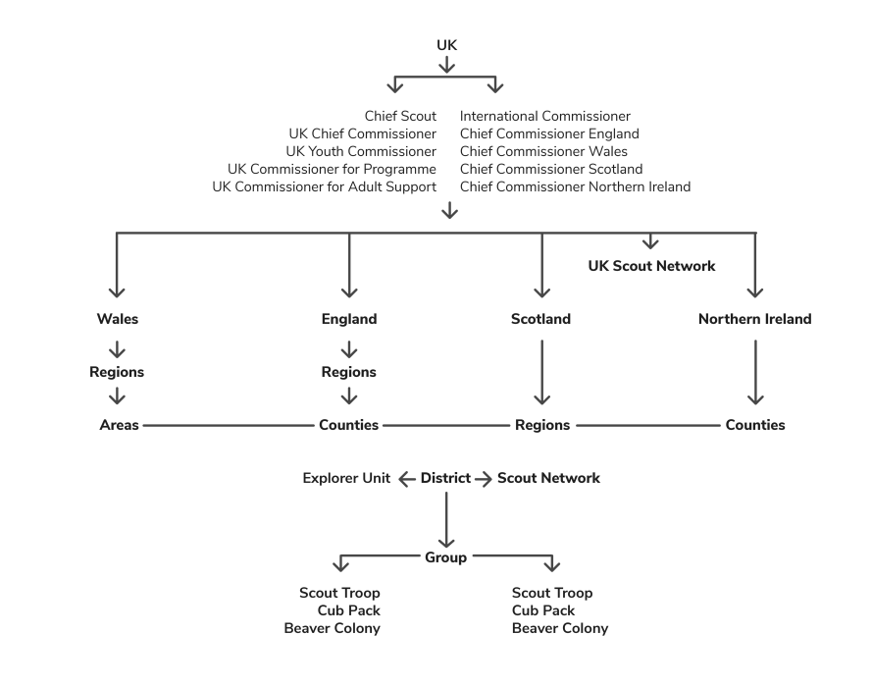

Adult Roles in Scouting & the Group
The descriptions below are just a very brief outline of the roles within our Group. Details of roles within the District and wider, also regarding the responsibilities of appointments, can be found on www.scouts.org.uk - to discuss where you fit in; firstly, speak to you Group Scout Leader

Group Scout Leader
The Group Scout Leader, amongst a variety of other things is responsible to the District Commissioner for the effective operation of the whole of the Scout Group. They are responsible for ensuring the Group has a team of ‘fit and proper’ adults who are well inducted and supported, and that a balanced programme is being delivered to all young people in the Group. A Group Scout Leader is responsible for all Leaders and Assistant Leaders in the Scout Group.

Leader
A Leader is responsible for planning and implementing a Balanced Programme for the Beaver Scout Colony / Cub Scout Pack / Scout Troop, subject to the general supervision of the Group Scout Leader and with the assistance of Assistant Beaver Scout/Cub Scout/Scout Leaders, Section Assistants and Skills Instructors. Leaders are Members of the Scout Association, are required to wear the appropriate uniform and agree to undertake all the necessary training for their specific role.

Assistant Leader
Assistant Leaders support the section Leader in delivering the Balanced Programme. This can mean anything from helping to plan and run games or activities, or helping to keep records up to date. The responsibilities of an Assistant Leader will depend on their own interests and on what they agree with the Leader. Assistant Leaders are Members of the Scout Association, are required to wear the appropriate uniform and agree to undertake all the necessary training for their specific role.

Section Assistant
All our sections need helpers. Outdoor activities and nights away require a certain number of adults in relation to the number of young people. So, by helping out whenever they can, section Assistants could be enabling an extra 6 (in the case of Beavers) or 12 (in the case of Scouts) young people to participate in Scouting. More importantly, section Assistants provide invaluable support to Leaders and Assistant Leaders, regularly attending meetings to help with things like running activities, making refreshments – all allowing the Leaders more time to deliver the programme to young people.

Occasional Helper/Parent
Parents and family members are encouraged, where possible, to help out a section in some way. Some sections will organise rotas where support can be given once or twice a term by all the parents in the section. This should be used as an opportunity to get involved in what the young people are doing. Adults who have a specific skill or interest can also choose to run a particular activity or event one evening a term. Such skills are invaluable to Scout Groups and can usually assist young people in gaining, or working towards, a particular badge.

Explorer Scout Young Leader (14-18)
The Young Leaders’ Scheme is designed for those aged 14-18 who are primarily interested in helping out in one of the younger sections (Beavers, Cubs or Scouts). Young Leaders will be members of the Explorer Scout section, which means that they can take part in all the activities and opportunities that Scouting in the Explorer Unit or District has to offer.
Group Chair
The Chair of the Group Executive Committee will manage meetings and will work with the relevant Commissioner or Group Scout Leader to ensure the Scout County/Area, District or Group operates in accordance with the Policy, Organisation and Rules of the Association. The Chairs are responsible for members of the Committee, including the Treasurer and Secretary.

Treasurer
Treasurers assist the Chairman in the effective administration of the Scout County/Area, District or Group by providing financial support. This could mean setting the annual budget or completing annual accounts. This role is ideal for someone who does not necessarily want to work directly with young people, but who is comfortable working with figures and budgets.

Secretary
Secretaries assist the Chairman in the effective administration of the Scout County/Area, District or Group by providing sound administrative support. This could mean ensuring the completion of the annual census or maintaining records of members of the County/Area, District or Group. This is the ideal role for someone who does not necessarily want to work directly with young people, but who is organised and enjoys administrative work.

Scout Active Support
Scout Active Support is a way for adults to volunteer some time to Scouting in a flexible way that suits them. Scout Active Support is a resource for managers of local Scouting including Group Scout Leaders, District Commissioners and County Commissioner, to use in whichever way is required

Training
Depending what role, you have within the Group will determine how much training, if any, you will need.
When taking up an appointment, as part of your role you may receive training to help you gain the skills that you need. The Scout Association operates a flexible modular Adult Training Scheme, which covers all of the knowledge you will need, and takes into account any skills and experience you may already have. The first thing to do is to get in touch with the Group Scout Leader, who together with the Local Training Manager and Training Advisers, will be able to explain the training scheme and help you decide what training is appropriate for you.

To find out more about your training and forthcoming courses speak to the Group Scout Leader or the District Training Adviser or check out https://www.scouts.org.uk/volunteers/learning-development-and-awards/training/learners/.

A Quick Checklist
If you are taking up a formal appointment, check if you have received the following resources.
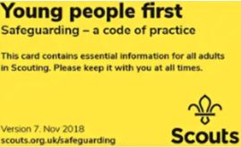 | Young People First (Yellow Card)  A small card which contains The Scout Association’s Safeguarding Code of Practice which alongside the Safeguarding Policy and Procedures states how leaders should behave.
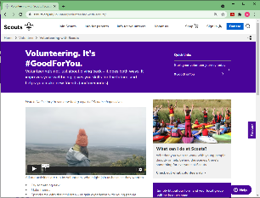 | Scouts.org.uk  The Scout national webpage has lots of useful information to support you volunteering with us. Visit www.scouts.org.uk and click on “info for volunteers” if you are running a section also check out the programme planning tool www.scouts.org.uk/programme-planner/plan

Membership Number & Access to your records on Compass
All members should be registered on Compass, which is the online system used to keep track of all members, and allows you to manage certain elements of your personal records. If you are registering for the first time, you will need your membership number, so please speak to your Group Scout Leader. You can access Compass to register using the following link: https://compass.scouts.org.uk/login/User/Register
OSM | Online Scout Manager (or relevant data management system)  Make sure you have the correct details and are able to log into the Groups online Scout Manager (OSM) account. Here we keep track of our membership details, as well as badge progress of our young people. You will also find out the details of our termly programme and what you can expect over the coming weeks. OSM is a private company that is not part of the Scout Association but many Scout Groups use it.

If you are missing something please contact your Group Scout Leader.

Where to go for More Information
There is a wealth of information and resources available to support you in your role, here are some you may find useful!
Group: | Add contact
District: | website
County: | website
The national Scout Information Centre is based at Gilwell Park and provides a single point of contact if you are seeking information or resources relating to any aspect of Scouting. It is open 9am to 5pm Monday to Friday.
- Email: info.centre@scout.org.uk
- Web: www.scouts.org.uk
- Volunteer resources: www.scouts.org.uk/volunteers/running-your-section/
- Brand Centre: www.scoutsbrand.org.uk/home
- Scout Shop: www.shop.scouts.org.uk/
- Programme Planning Tool: www.scouts.org.uk/programme-planner/plan
- For information on sections and their badges; www.scouts.org.uk/information-for-parents/what-do-scouts-do/

Frequently Asked Questions
Will I get paid or get expenses?
The Scout Association is a voluntary organisation, and you will not be paid for your role. However, no adult should feel that cost prohibits them from taking up a role in Scouting, and we are committed to reimbursing out of pocket expenses for all volunteers. You should speak to your Group Scout Leader to find out how this works and what policies are in place with the Group.

Where does religion fit into Scouting?
The Scout Association does not identify itself with any one religion and is open to all faiths and people who identify as being not part of any religion. Adults in Scouting should aim to encourage the spiritual development of young people in whichever faith they identify themselves with.

Who is responsible for administering first aid if there is an accident?
All trained adults in Scouting should have an up to date first aid certificate of First Response level or equivalent and are responsible for the young people in their care. On a camp or activity one person should be designated first aider. If an incident requires any consultation with or treatment by a doctor, dentist or hospital the Information Centre should be notified, and the District Commissioner. The Incident Report Form (from HQ) has to be filled in by an impartial person. Please make sure all incidents are reported to the Group Scout Leader.

What insurance do I/the young people have?
All Members of The Scout Association have personal accident insurance and legal liability cover whilst on Scouting activities. Current details can be obtained from Unity Insurance on 0345 040 7702 or www.unityinsuranceservices.co.uk/scout-insurance. You can also talk to the Group Scout Leader if you have any questions.

10 things you may not know about Scouting
- Scouting is for girls as well as boys, and started mixing in 1976
- Scouting is a global movement and is currently active within 216 countries and territories
- Young people can join at any stage of their development, from aged 5 years and 9 months…
- The Scout Association is a registered charity.
- Robert Baden-Powell, the Founder of Scouting was recently voted the 13th most influential person of the 20th Century.
- Famous former Scouts include Sir Paul McCartney, Stephen Spielberg, David Beckham & Sir David Attenborough.
- Each day 100,000 people in the UK take part in Scouting activities.
- Scouting for Boys, Baden-Powell’s blueprint for the Scout Movement is one of the most popular books of all time.
- Scouting was 100 years old in 2007.
- Of the 27 men to travel to the moon on the Apollo 9 through to Apollo 17 missions, 24 were Scouts, including 11 of the 12 men who physically walked on the moon's surface, and all three members of the crew of Apollo 13.

Enjoy and thank you!
This is just the beginning of your journey in Scouts, and with our Scout Group. We hope you found this brief guide useful and informative. There is a wealth of information on the various websites mentioned above, but more than that, you are now part of a successful Group, in a very active District, within a County full of opportunities, and a Scouting World full of adventure… all filled with Children and Adults who will no doubt help answer any questions you might have.
Scouting has been enjoyed by Millions, for over 100 years… hopefully you will enjoy being a part its next 100 years!

