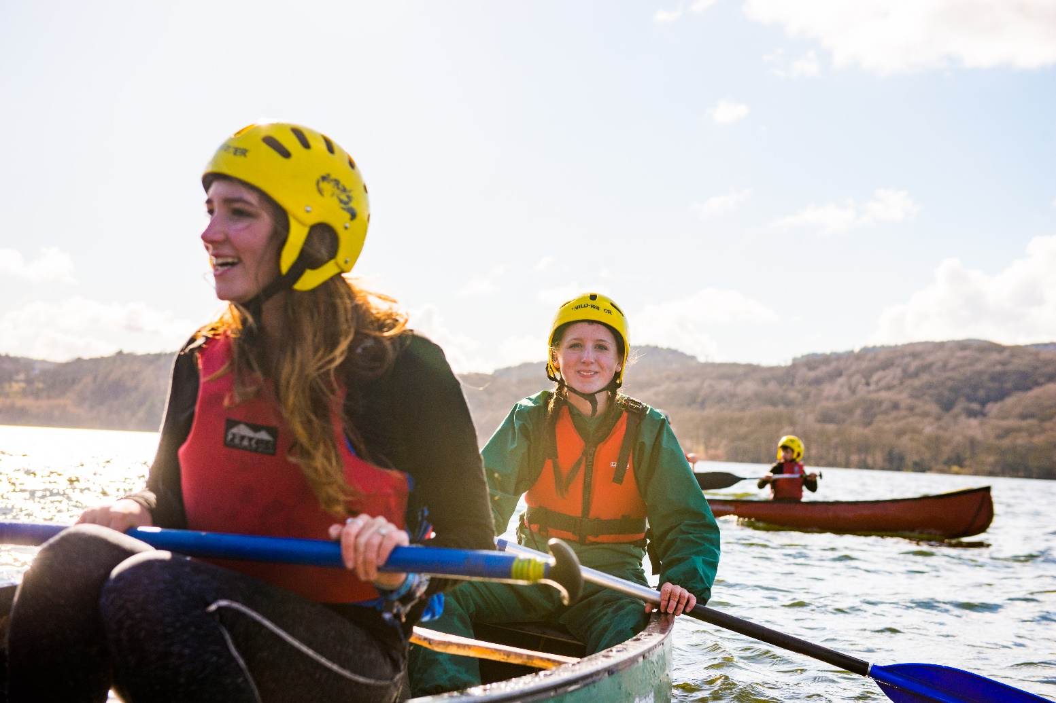
District Commissioner

Information for anyone considering the role of District Commissioner for XXX

About us
Overview of Scouting
We are the UK’s biggest mixed youth organisation. We change lives by offering 6 to 25 year olds fun and challenging activities, unique experiences, everyday adventure and the chance to help others so that we make a positive impact in communities.
Scouts helps children and young adults reach their full potential. Our members gain valuable skills for life including teamwork, time management, leadership, initiative, planning, communication, self-motivation, cultural awareness and commitment. We help young people to get jobs, save lives and even change the world.
What do Scouts do?
Scouts take part in a wide range of activities as diverse as kayaking, abseiling, expeditions overseas, photography, climbing and zorbing. As a Scout you can learn survival skills, first aid, computer programming or even how to fly a plane. There’s something for everyone. It’s a great way to have fun, make friends, get outdoors, express your creativity and experience the wider world.

What do volunteers do?
This everyday adventure is only possible thanks to our team of adult volunteers, who support Scouts in a wide range of roles from working directly with young people, to helping manage a local community based Group, to being a charity Trustee. We help volunteers get the most out of their experiences at Scouts by providing opportunities for adventure, training, fun and friendship.
Our award winning training scheme for volunteers means that adults get as much from Scouts as young people. Our approach focuses on what you want to get out of volunteering with Scouts, while respecting how much time you can offer. Over 90% of Scout volunteers say that their skills and experiences have been useful in their work or personal life.

Key facts and figures
The Scout Association is a UK charity founded in 1907 and now boasts a membership of over 620,000 young people and adult leaders. We are the largest mixed youth movement in the UK. Scouting activity is delivered through 7,000-plus community based Scout Groups nationwide.
Scouting is widely recognised and is one of the most trusted charities in the UK, giving it a significant level of influence and responsibility. Scouting’s greatest strength lies in its grass roots. It is locally that Scouting is best able to identify and work directly with young people most in need.
We believe that through the everyday adventure of Scouting, young people and adult volunteers regularly experience new challenges that enrich and change their lives.
The current focus for the Trustees and those in Scouting in the UK is delivering our strategic vision.

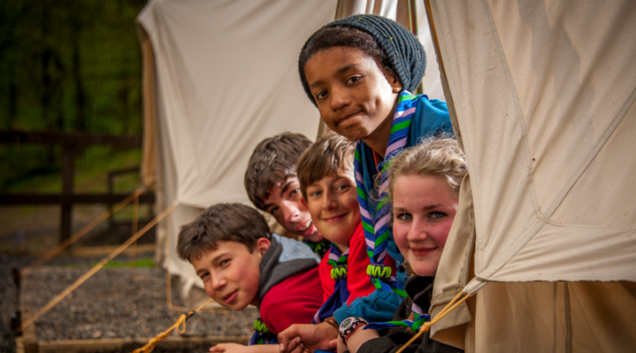
Our strategy
A new strategic plan for Scouting across the UK is currently nearing completion to secure a strategic direction through to 2023 and to grow on the success of the current plan. Team UK (the team of commissioners that leads Scouting across the UK) will play a key part in leading the delivery of this strategy. More details on the work towards our new plan are available at www.scouts.org.uk/ourplan

By 2023 we will have prepared more young people with skills for life, supported by amazing leaders delivering an inspiring programme. We will be growing, more inclusive, shaped by young people and making a bigger impact in our communities.
Further information on our strategic objectives are provided on our website at www.scouts.org.uk/ourplan

Scouting’s fundamentals

Our mission
Scouting exists to actively engage and support young people in their personal development, empowering them to make a positive contribution to society.

Our values
As Scouts, we are guided by these values:

Integrity

Respect

Care

Belief

Co-operation
Further information on our fundamentals, including details of our values, are provided on our website at http://scouts.org.uk/about-us/key-policies/fundamentals-of-scouting/

Scouting’s key policies
In common with all members in Scouting, District Commissioners are required to promote and follow our key policies. The policies cover:

Child Protection

Equal Opportunities

Religion

Safety
These policies are fully explained on our website at http://scouts.org.uk/about-us/key-policies/

XXX Scouts
XXX District, is located within XXX County, and is made up of XXX Groups. This covers XXX (geographical area). XXX Scouts’ total membership is currently XXX, which includes:
- XXX Beaver Scouts (6 - 8 year olds)
- XXX Cub Scouts (8 - 10 ½ year olds)
- XXX Scouts (10 ½ - 14 year olds)
- XXX Explorer Scouts (14 – 18 year olds)
- XXX Network members (18 – 25 year olds)
- XXX Adults (18+ year olds).

The current vacancy
We’re currently looking for a District Commissioner. This is a management role, and we need someone who can provide leadership, motivation and guidance to our other adult volunteers.
A large part of this role involves supporting managers of local Groups. For any adult volunteer in Scouting, their manager will be a regular point of call for support.
You don’t need any prior experience of Scouting to apply for this role: we’ll make sure you’re fully trained and supported.
The management structure of Scouting is as follows:

(Please note that we have used the term ‘Scout County’ throughout this pack: in Wales and Northern Ireland these are known as Areas, and as Regions in Scotland.)
District Commissioners support other managers, known as Group Scout Leaders, and other volunteers. Adults at every level need support to ensure that they are motivated, inspired and focused on providing first-class Scouting. A good manager thanks other volunteers for their hard work, and helps to make sure that they feel happy and supported, week after week.
The District Commissioner will also provide direction for the District, and will help others see the bigger Scouting picture through solid leadership.
We believe that everyone in management roles within Scouting should adopt an approach that combines the skills of both leadership and management.

Core Skill Areas

We’ve identified six core skill areas that make a good Scouting manager:

1. Providing direction
A good District Commissioner will create a vision for Scouting in their District, and provide clear leadership to implement that vision.
2. Working with people
It is vital that a District Commissioner can create team spirit amongst the other volunteers they work with, and can form effective working relationships based on trust and the fundamental principles of Scouting:
- integrity
- respect
- care
- belief
- cooperation
3. Achieving results
Good District Commissioners ensure that goals are achieved, plans are seen through to completion, and that good relationships are maintained within and between Scout Groups. Forging links within the local community is also an important aspect of development.
4. Enabling change
It is important for District Commissioners to encourage volunteers to think of creative ways to improve Scouting across the District. They should then provide the support to implement appropriate changes.
5. Using resources
A good District Commissioner will ensure that information and resources are available, helping volunteers across the District to continue to provide excellent Scouting opportunities to young people.
6. Managing time and personal skills
A good District Commissioner should use their time effectively, and be willing to continue to learn and improve their skills.

How to apply
Process
Thank you for your interest in volunteering. On the following pages you will find a role description and the person specification. The District Commissioner nomination and application forms are on pages X and X.
You can apply for the role yourself using the application form, or nominate someone else using the nomination form. Nominated people are under no commitment to apply unless they wish to.
Shortlisting will be based solely on the information provided by each candidate in their application form. All applications should address the requirements of the role, as laid out in the role description and person specification

Key dates
The closing date for applications is XXX
Interviews will be held on the XXX at XXX

Further information
For more information, or for an informal chat about this vacancy, please contact:
Name:
Phone:
Email:

The role - District Commissioner

Role description
Outline:
To manage and support the Scout District to ensure it runs effectively, and that Scouting within the District develops in accordance with the rules and policies of The Scout Association. To ensure the District provides good quality Scouting for young people and proactively supports and manages adults in the District.
Responsible to:
County/Area/Regional Commissioner(s) (or deputies, if appropriate).
Responsible for:
Deputy District Commissioners, Assistant District Commissioners, Group Scout Leaders, District Explorer Scout Commissioner, District Scout Network Leaders, District Scout Active Support Managers, District Scouters, District Advisers, Nights Away Advisers, District Media Development Manager.
Main Contacts:
County Commissioner/Area Commissioner/Region Commissioner (Scotland), Deputy District Commissioners, Group Scout Leaders, District Explorer Scout Commissioner, District Scout Active Support Managers, District Scout Network Leaders, Assistant District Commissioners, members of the District Executive Committee and its sub-committees, County/Area/Regional(Scotland) Scout Network Commissioner, , County/Area/Regional(Scotland) Training Manager, Local Training Manager, members of the Regional Development Service, Local Development Officers or Field Commissioner (as appropriate), other District Commissioners, members of the local community, schools and other youth organisations.
Appointment requirements:
Must complete the relevant training (a wood badge) within three years of taking up the role. Must be eligible for charity trustee status (as a member of the District Executive Committee). It is expected that whilst volunteering for this role you will undertake regulated activity.

Main Tasks
- Ensure that the District thrives and has the best systems in place to support the Groups, to support all adult volunteers in the District and to develop Scouting in the District
- Provide line management and support to the adults in the District that directly report to you including setting objectives for their work and holding regular reviews and one-to-one meetings.
- Produce a vision for the District and implement a development plan to meet that vision.
- Ensure that Scouting in the District is attractive to young people and adults from all backgrounds in the District.
- Ensure that the District has an adequate team of supported and appropriate adults working effectively together and with others to meet the Scouting needs of the area.
- Ensure that problems within the District are resolved so that excellent Scouting is provided to young people in the District.
- Work with the County/Area/Regional(Scotland) Commissioner and other District Commissioners in the County / Area / Region(Scotland) to ensure that the Scouting in the County / Area / Region(Scotland) thrives.
Note: Some of the tasks for which the County Commissioner is responsible may be delegated to others in the County, including a Deputy County Commissioner, if appointed.

Person specification

Knowledge and experience:
Ability to manage adults effectively | Essential
Understanding of the challenges of working in the voluntary sector | Desirable
Experience of working with young people and/or community work with adult groups | Desirable
Experience of working in the Scout or Guide Movements as an adult | Desirable

Skills and abilities:
Excellent written and oral communication skills | Essential
Provides advice and guidance effectively to others | Essential
Provides inspirational leadership for the District | Essential
Provides strategic direction for the District | Essential
Motivates adults volunteering in the District | Essential
Can build, maintain and facilitate effective working relationships with a wide range of people | Essential
Enables others to identify issues, clarify objectives, develop attainable objectives and gain the necessary skills and confidence to work as an effective team | Essential
Ability to negotiate compromises | Essential
Plans, manages and monitors own tasks and time | Essential
Can construct and implement long-term plans that improve and expand the Scouting offered to young people, and identify any training, resources and other needs required to undertake this work | Essential
Can use basic computer software | Essential

Personal qualities:
An understanding of the needs of adult volunteers | Essential
Flexible approach | Essential
Self-motivated | Essential
Able to work as part of a team and promote good teamwork | Essential
Resourceful, energetic and enthusiastic about the job | Essential
Acceptance of the fundamentals of the Scout Movement | Essential

Nomination Form
If you think you know the right person for this District Commissioner role, please complete the nomination form below. Nominating an individual does not commit them to applying, but, if they choose to, they will be required to complete a more thorough application form.
...Please insert necessary GDPR statement here...

Nominee’s details
Name
Telephone number
Email address
Please outline why you felt motivated to nominate this person for the role of District Commissioner:

Your details
Nominated by
Telephone number
Email address
Please return this form to:
The closing date for receiving nominations is:

Application Form
If you are interested for applying for this District Commissioner role, please complete the application form below.
...Please insert necessary GDPR statement here...
Name
Telephone number
Email address
Please outline why you want to apply for the role of District Commissioner:
Please briefly explain why you would be suitable for this role, including professional and voluntary experience, within or outside Scouting (refer to role description):
Please describe the skills you would bring to this role (refer to person specification):
Please return this form to:
The closing date for receiving nominations is:

