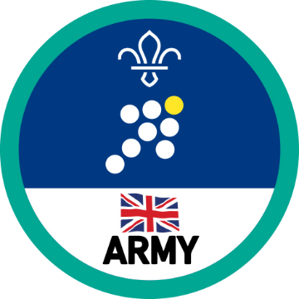
Explorers Leadership Activity Badge

Previous requirements:

The requirements for this badge have been recently updated, however if you’re already working toward the badge or have planned activities in your programme you can continue using the requirements listed here until the end of 2023.

Successfully lead a team of Explorers thoughout the course of a project.

There are lots of possibilities but whatever you do, you’ll need to:

Set a goal for the project and individual targets for team members

Take suggestions and feedback from team members into account and act on them

Teach team members new skills that may be required for the project

Manage any tricky situations or people and find compromises

Give clear instructions, motivate your team, ensure that you are on track and make sure everyone is safe.

Take an active role in the running of an activity linking with the Scout section.

Help a new Explorer Scout to be part of the Unit and help them understand what is expected.

Help a group of Explorers or members of a younger sections develop a Scouting skill.

Represent the views of other Explorer Scouts (for example at a District Explorer Scout Forum or similar) and report back to them afterwards.

Updated requirements:

We’ve recently worked with Explorer leaders, and the British Army, to update the requirements for this badge. You can find the new requirements on the Scouts website. Units who are already working towards this badge can continue working towards the older set of requirements on this page until the end of 2023.

