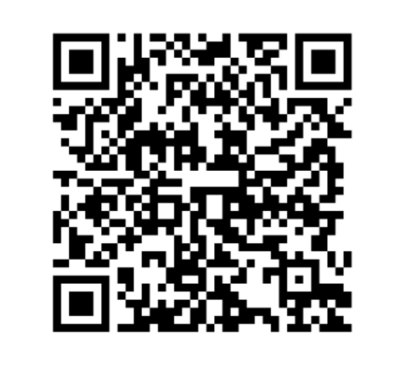
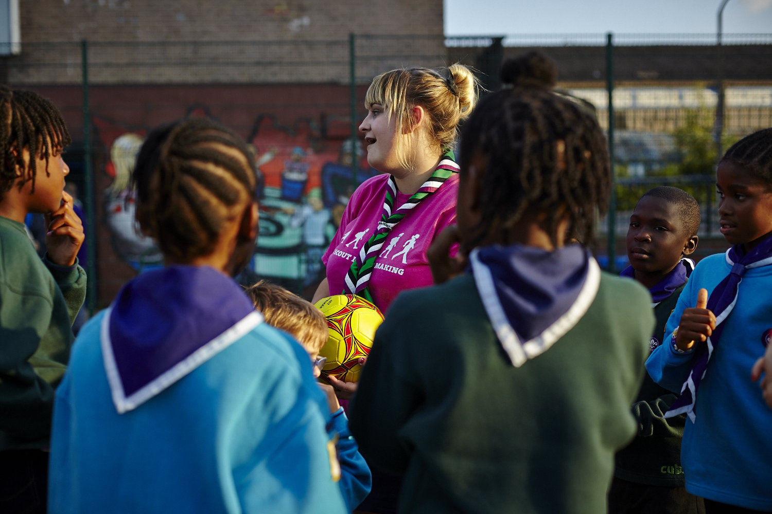

Something doesn’t feel right?

Let us know.

Use our anonymous reporting form to tell us about unfair treatment related to identity, such as gender, race or religion, you’ve seen, heard or experienced at Scouts.
We’ll use what you share to create resources for volunteers tackling discrimination and help build a more inclusive Scouts where everyone feels they belong.
Tell us what you’ve seen, heard or experienced. If it didn’t feel right, we’d like to know about it.

Visit scouts.org.uk/volunteers/equity-diversity-and-inclusion/listening-tool

